CULTURE: HOME
- Match the words to their synonyms
- take down | - move
- float | - expensive
- carry | - swim
- luxurious | - take apart

- Match the words to the pictures

1 a floating house | 4 a tent | 7 a sea view
2 a narrow boat | 5 a lighthouse | 8 a luxurious room
3 solar panel | 6 a students’ hostel | 9 a yurt

A 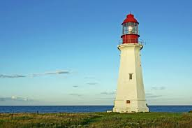 | B 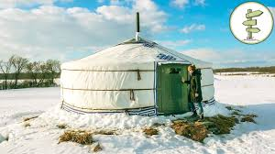 | C 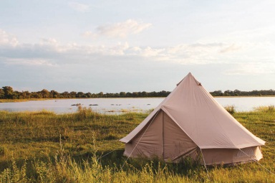
D 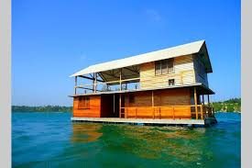 | E 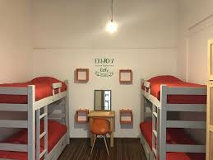 | F 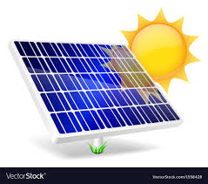
G 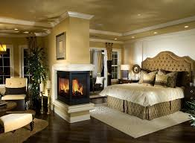 | H 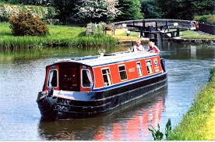 | I 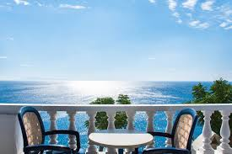

- Watch the video. Tick (√) the things that are mentioned.

1 – floating houses
2 – rooms with the sea view
3 – solar panels
4 – narrow boats
5 – a lighthouse
6 – students’ hostels
7 – tourist tents
8 – yurts

- Put T (true) or F (false) next to the sentences. Then watch the video and check.
Example: In Denmark some students live in floating houses. T

- Rooms in floating houses come with the sea view.
- Floating houses are made on the basis of cargo ships.
- Narrow boats are of a particular colour.
- You can choose where to live in London if you have a narrow boat.
- Yurts are made of wood and wool.
- People in Mangolia take down their yurts in 4 hours.
- Girls in Siberia wear colourful clothes when it’s cold.

- Tick (√) the things that happen in the video.
Watch the video and check

